Lab 09

Memory, Cache, Loops and Array

Memory Instructions: In RISC-V assembly, memory instructions like lw (load word) and sw (store word) are essential for moving data between the processor’s registers and main memory. The lw instruction loads a 32-bit value from a specified memory address into a register, allowing the CPU to perform computations on data stored in memory. Conversely, sw stores a value from a register back into memory, preserving the result for later use or for other parts of the program.
Why:
• CPU registers are limited in number and size, so most data must reside in memory.
• lw and sw allow programs to access larger datasets beyond registers.
• They enable updating variables and maintaining results across program execution.
• Facilitate efficient computation by moving data between memory and registers.
• Demonstrate a typical load-compute-store cycle:
- Load values from memory (lw)
- Compute using registers (add)
- Store results back to memory (sw)

# memory[0] = ?, memory[4] = ?
lw t0, 0(x0)
lw t1, 4(x0)
add t2, t0, t1
sw t2, 8(x0) # store result at memory[8]

Explanation:
- RISC-V memory access uses base + offset addressing: lw t0, OFFSET(BASE_REGISTER).
- 0(x0) → base = x0 (always 0), offset = 0 → memory address = 0 → loads 1st word.
- 4(x0) → base = x0 (0), offset = 4 → memory address = 4 → loads 2nd word.
- Each .word in memory occupies 4 bytes, so addresses increment by 4 for each word: 0, 4, 8, 12…
- Example mapping:
  - memory[0] = 5 → first word
  - memory[4] = 7 → second word
  - memory[8] = result → third word
- x0 acts as a zero base, offsets point to word positions in memory.

Output
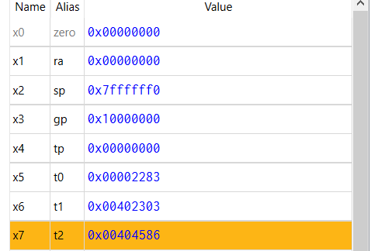

Output in memory
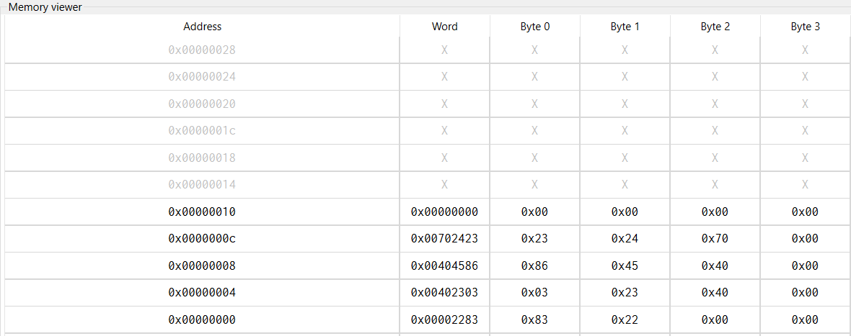

Explanation:
- lw t0, 0(x0): Loads the 32-bit value located at memory address 0 into register t0.
- lw t1, 4(x0): Loads the 32-bit value located at memory address 4 into register t1.
- add t2, t0, t1: Adds the two register values (from t0 and t1) and writes the sum into t2.
- sw t2, 8(x0): Stores the computed value in t2 into memory address 8.

Memory instructions with actual data.

.data
num1: .word 10 # memory[0] = 10
num2: .word 20 # memory[4] = 20
result: .word 0 # memory[8] = 0 (to store result)

.text
la t0, num1 # load address of num1
lw t1, 0(t0) # load value 10 into t1

la t0, num2 # load address of num2
lw t2, 0(t0) # load value 20 into t2

add t3, t1, t2 # t3 = 10 + 20

la t0, result # load address of result
sw t3, 0(t0) # store sum 30

Explanation:

- .data section → declares and initializes memory variables (num1 = 10, num2 = 20, result = 0).
- .text section → contains the instructions to execute.
- la t0, num1 → loads the address of num1 into register t0.
- lw t1, 0(t0) → loads the value at num1 (10) into t1.
- la t0, num2 → loads the address of num2 into t0.
- lw t2, 0(t0) → loads the value at num2 (20) into t2.
- add t3, t1, t2 → adds the two values (10 + 20) and stores the result in t3.
- la t0, result → loads the address of result into t0.
- sw t3, 0(t0) → stores the sum (30) into memory at result.
- Overall → demonstrates a load-compute-store cycle using initialized memory values.

Output in memory
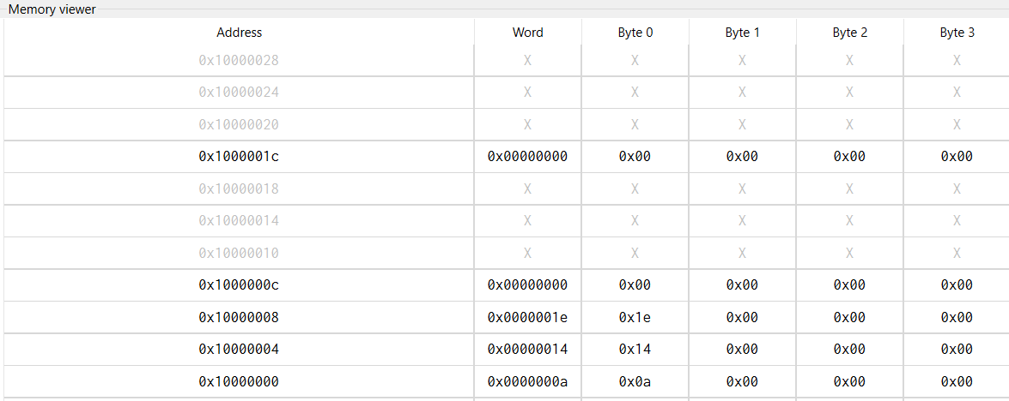
Cache View (Instruction)
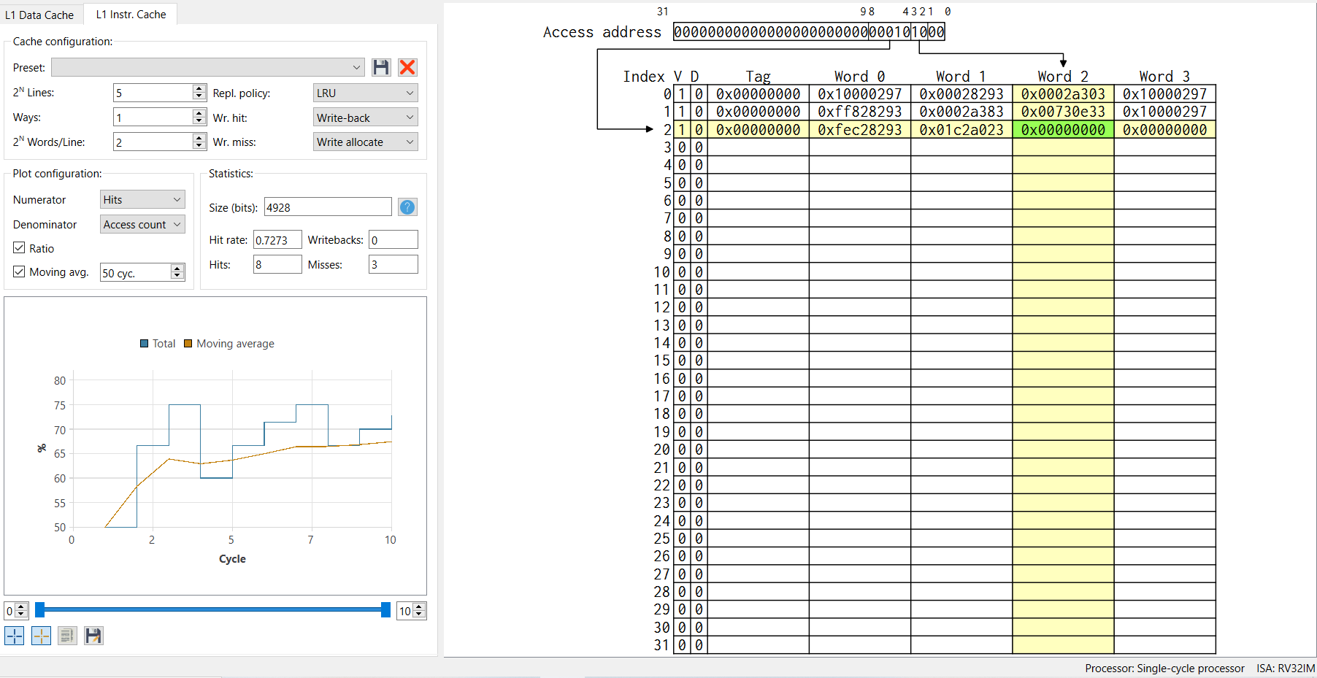

Cache table explanation (right side of the image)
- Index → cache line index (0–31)
- V → valid bit (1 = data present)
- D → dirty bit (1 = modified, not written back yet)
- Tag → upper address bits identifying memory block
- Word 0–3 → data in cache line (each line has 4 words)
- Line 0: contains previous data (0x10000297, 0x00028293, …)
- Line 1: contains another block of memory
- Line 2: shows your recently stored value (0x00000000 in Word 2 → likely corresponds to result)
Address mapping
- Access address: 0000...0100 = decimal 4 → corresponds to memory[4] (num2)
- Cache index calculation: lower bits of address select line → you see index 2 highlighted
- Tag: upper bits of address → helps identify which memory block is in the cache line

Statistics & plot (bottom-left)
- Hit rate: 0.7273 → ~73% of accesses found in cache
- Hits = 8, Misses = 3 → initial loads (num1, num2, result) cause misses; subsequent accesses hit cache
- Moving average shows how the hit rate evolves over cycles

Summary
- This program accesses memory 3 times for num1, num2, and result.
- Each lw/sw triggers a cache lookup, which may cause a miss or hit.
- Cache table shows how data is stored in L1, which line, which word, and if it’s dirty/valid.
- The graph tracks overall cache performance as the program runs.

Cache View (Data)
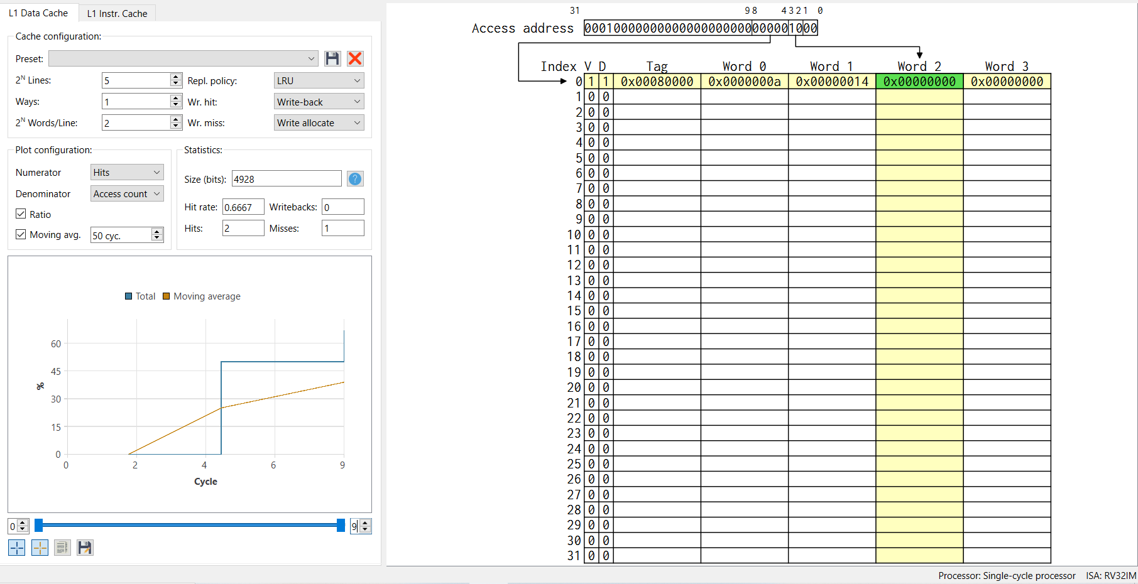
Arrays
.data
myArray: .word 5, 10, 15 # Define an array with 3 numbers

.text
la t3, myArray # Load base address of array into t3

lw t0, 0(t3) # Load first element (5) into t0
lw t1, 4(t3) # Load second element (10) into t1
lw t2, 8(t3) # Load third element (15) into t2

Explanation:
- .data section declares myArray with 3 elements.
- la t3, myArray loads the base address of the array.
- Each lw instruction loads one element into a temporary register.
- Offsets increase by 4 bytes per word: 0, 4, 8.

Output
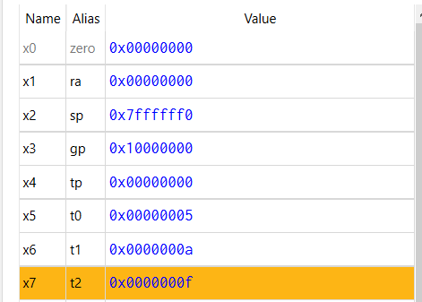
Data in memory
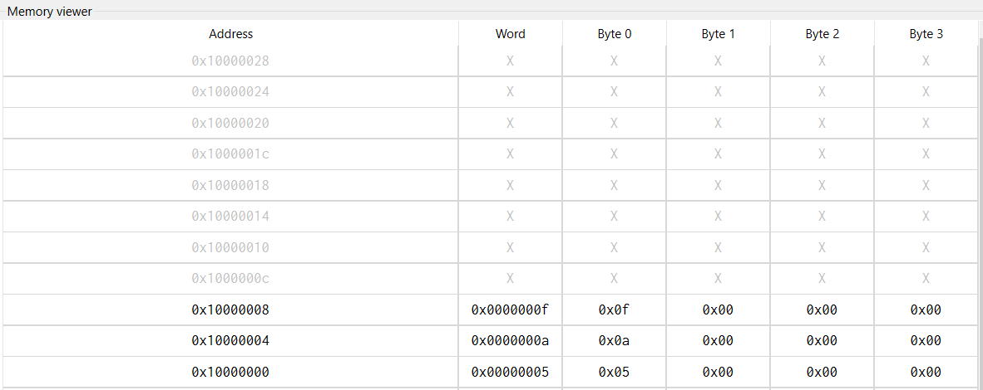
Loop example
addi t0, x0, 5 # t0 = 5 (loop counter)

LOOP:
addi t0, t0, -1 # t0 = t0 - 1
bne t0, x0, LOOP # If t0 != 0, repeat loop

Loop using two registers (Like in EMU8086)
addi t0, x0, 0 # counter = 0
addi t1, x0, 5 # limit = 5

LOOP_TWO:
addi t0, t0, 1 # counter++
bne t0, t1, LOOP_TWO # stop at 5
Loop with condition
addi t0, x0, 5 # counter = 5
addi t1, x0, 0 # sum = 0

LOOP_COND:
addi t2, x0, 3 # value to skip = 3
beq t0, t2, SKIP # if counter == 3, skip

addi t1, t1, 1 # sum++

SKIP:
addi t0, t0, -1 # counter--
bne t0, x0, LOOP_COND

Exercise:
Task 1: Define array, iterate using loop and computer sum of array.
Task 2: Explore stack operations in Ripes with an example code.
Task 3: Pop and push 5 values, and analyze the cache (both instruction and data).

